IFHS ANNUAL HANDBOOK

2023 £2
Does not include entry to the Summer Show
SUMMER SHOW
15th July 12.30 – 5.30pm
Seymour Field
(Adults £5, children under 16 free – CASH only)

AUTUMN SHOW
23rd September 3 – 5pm (free entry)
Community Club Hall

Please keep this Handbook safe.
You will need it for all three shows.
SPRING SHOW
15th April
3 – 5pm (free entry)
Community Club Hall

2017

Membership of the IFHS is open to all.
The Society’s objects are to encourage and promote public interest in horticulture, including the culture of flowers, fruit and vegetables.
Find us on Facebook @ IFHS.org

Every year the society organises:-
- Three Shows – all classes are open (anyone can exhibit).
- Outings to RHS and other gardens and events.
- AGM which includes a review of the society’s activities during the year and refreshments.

Membership Rates: Ordinary Single £6 Ordinary Joint £10 Concessions Single £5 Concessions Joint £8
Joint = 2 Adults at the same address
A £3 surcharge for postage applies to members outside the area.

Members are entitled to
- Free admission to all our Shows and Meetings except the summer show which we no longer organise and from which we now get no income.
- Free Annual Handbook containing show schedules and entry forms delivered to your address
- Access to RHS Garden Ticket which allows reduced admission charges (one third off) for two adults to all RHS Gardens
- 10% discount for horticultural purchases at Abercorn Garden Centre, Beehive Lane Chelmsford,
- 10% discount for horticultural purchases at Greenbrook Garden Centre, Ongar Road, Chelmsford
For more information about joining, exhibiting, helping with events or joining the committee, contact any of the committee members listed opposite or visit our website www.ifhs.org.uk

President: The Lord Petre
Vice Presidents: Mesdames: D. Crowder, E.A.Oxley, C. James
Messrs.: A. Cork, G. James

Officers and Committee 2023

Chair: Sarah Duke-Woolley,
15 The Heythrop, Ingatestone 07919 447227
Email: sarah@beechamresearch.com
Treasurer: David Fowle,
10 The Heythrop, Ingatestone 01277 350823
Secretary: vacant
Membership Secretary: Richard Emond
Doc_Emond@hotmail.com
Competition Secretary: Janet Collins,
Ashtrees, Little Hyde Lane, Fryerning 01277 352534
Assistant Competition Secretary: Gill Harste,
2 Park Drive, Ingatestone 01277 352444
Committee Members:
Marion Clarkson, Helen Gillings, Sarah Collins, Ben Heywood,
Matthew Shaw
Dates for your Diary 2023
SPRING SHOW – Saturday 15th April
Coach Trip to RHS Wisley, Spring Craft and Design Show - Saturday 29th April
Visit to Sheila Chapman’s garden - Wednesday 28th June
SUMMER SHOW – Saturday 15th July
AUTUMN SHOW – Saturday 23rd September
AGM – Thursday 16th November, 7.30pm

Welcome to our 2023 Annual Handbook.
This contains the schedules and rules for all three of our shows.
Please keep this somewhere safe as you will need it to enter the Spring, Summer and Autumn shows.
I am very pleased to welcome Matthew Shaw to the committee. Last year’s summer show was a disappointment to all. Certainly if it could go wrong then it did go wrong. Even the weather was against it as it was exceptionally hot making the field an unpleasant place to be.

The Parish council have agreed to take over running the show for the forseeable future. It will be a traditional show with the Scouts running the barbeque and with the bar run, this year, by the Ingatestone Cricket Club.The society will continue to run the horticultural competition in the large marquee which, to save unnecessary expense, we will share with the Parish Council. They have decided to charge £5 for all adults (no concessions), cah only, for entry to the field but children under 16 will continue to be free. Unfortunately the IFHS can no longer offer free entry to members. The Society is no longer part of the organisation of the show and will not receive any of the money taken at the gate. If you wish to enter the competition you will be able to put your entries in the marquee in the morning and attend the prize giving and collect your entries at the end of the show without charge.

I am pleased to say that the changes to the way we hold the Spring and Autumn shows have been successful although we felt that they went on a little too late so this year we will open and finish a little earlier. Both will continue to be held be held in the Community Club hall as it makes social distancing easier. Exhibits will need to be staged ready for judging between 12.30 and 1.30pm for the Spring show and 12 – 1.15pm for the Autumn show. They will be open to the public from 3 – 5pm and there will be refreshments available as we are hoping it will be a more sociable event than it has been in the past.

The visit to Peacocks was very enjoyable and we have arranged a similar vist, in which you use your own transport, for June this year. It is to see Sheila Chapman’s garden in Chelmsford. Sheila is well known for her work in producing clematis varieties and her garden is in the yellow book. We have arranged an evening visit so that members can visit during the working week. See page 10 for details.

Ann Monk is also hoping to arrange more coach trips this year after the success of the September visit to Wisley. The first will be back to Wisely for their Spring Craft and Design show on Saturday 29th April. See page 9 for details. We are also hoping to arrange a visit to Kew in September but no details are available yet.

Finally another member, Linda Fox, has joined the Parish Council’s Climate Emergency Working Group which is developing unused areas into gardens and green spaces. We hope to support this activity with advice, expertise and plants. We also hope to adopt and look after a planter on the High Street. If you would like to be more involved in any of our activities please get in touch with any member of thee committee.

Sarah Duke-Woolley (Chair IFHS) Phone : 07919 447227 Email: sarah@beechamresearch.com
Never Entered a Show?
Here’s How To Have a Go
You do not have to be a member of IFHS to enter our shows.

- Read through the schedule for the show you wish to enter. If you have never entered the show before you will be classed as a Novice.
- Refer to the notes on pages 37 - 40 and the rules for entry on pages 7 and 8 for the Spring Show, pages 27 and 28 for the Summer Show and page 35 for the Autumn Show.
- As the date of the Show approaches go out into your garden and/or allotment and see what there is that you could enter.
- Decide which classes you want to enter and fill out the entry form. Put the entry form in an envelope with the and take it to the Community Centre. Place it in the IFHS box in entrance hall (the front entrance on the High Street) by the date specified on the entry form. This makes life easier for us but you can still enter on the day of the Show although there is a late entry fee.
- Handicrafts and Domestic entries can be prepared ahead. Flowers, fruit and vegetables need to be fresh. Use your judgement as to when to cut them.
- Fruit and Vegetables should be uniform in size.
- When being judged some fruits and vegetables may be cut or snapped.
- It is important to conform to the correct number of stems, fruits or vegetables asked for in the schedule.
- If you are not sure if your exhibit is a flowering shrub or a hardy perennial, ask. We are happy to help.
- In the Domestic classes cakes, biscuits, scones etc. should be presented on a plate with a doily and placed in a large transparent plastic bag. Please do not use cling film. It is too dificult to replace after the judging.
- Please be aware that entries in the Domestic classes will be tasted as part of the judging.
- If possible, label plant material with both kind and variety as this makes the exhibits more interesting. Cards are availble for this on the day of the show.
- Finally, enjoy the show. You may even come away with a cup or a certificate.


Spring Show
Saturday 15th April 2023
Held at the Community Club Hall
Judge: Clive Emberson
Open to the public at 3pm

Prizes will be awarded as follows:
Pilling Dunn Cup for Highest Points in show £10 Highest Points in show
Trevor Cracknell Trophy (Best Daffodil) £6 2nd Highest Points in show
Ethel Ellis Memorial Cup (Best Exhibit in show) £4 3rd Highest Points in show
Classes marked * (19, 20, 21, 22) to be exhibited in exhibitors own clear, colourless glass;
All other classes in Sections A & B to be exhibited in one vase supplied by the Society.

Section A: DAFFODILS and NARCISSI Points
- One trumpet Daffodil (Division 1) any variety 4 3 2
- 3 Blooms Trumpet Daffodils (Division 1) any variety 4 3 2
- One Large Cupped Daffodil (Division 2) any variety 4 3 2
- 3 Blooms Large Cupped Daffodils (Division 2) any variety 4 3 2
- One Small Cupped Daffodil (Division 3) any variety 4 3 2
- 3 Blooms Small Cupped Daffodils (Division 3) any variety 4 3 2
- One Double Daffodil (Division 4) any variety, one flower to stem 4 3 2
- 3 stems Miniature Daffodils / Narcissi any variety 4 3 2
(Blooms not to exceed 50mm in diameter)
- One Stem any variety not shown in classes 1 – 8 4 3 2
- One vase Daffodils / Narcissi, 5 Stems, any ONE variety 4 3 2
- One vase Daffodils / Narcissi, 5 Stems, more than one variety 4 3 2

Section B: OTHER GARDEN FLOWER
12. One Specimen Tulip, single flower variety 4 3 2
13. One Specimen Tulip, double flower variety 4 3 2
14. 3 Stems Tulips, three separate varieties 4 3 2
15. 3 Stems Tulips, any ONE variety 4 3 2
16. Any Other Flower grown from bulbs or corms, 3 stems 4 3 2
17. Flowering Shrub or Tree, ONE kind only, any number of stems 4 3 2
18. Flowering Shrub or Tree, more than one kind, any number of stems 4 3 2
19.* Polyanthus, Primrose, Cowslip,or Auricula, 3 stems (see note above) 4 3 2
grown in the open
20.* Pansies or Violas, 6 stems (see note above) 4 3 2
21.* Hellebore, one stem (see note above) 4 3 2
22.* Camellia, one bloom (see note above) 4 3 2
23. Mixed Garden Flowers, any number of items 4 3 2
Section C: MISCELLANEOUS CLASSES
24. One Pot Plant in Flower 4 3 2
25. Rhubarb, four sticks 4 3 2
26. Any Seasonal Vegetable, one kind 4 3 2

CLASIFICATION OF DAFFODILS (NARCISSI): DIVISIONS 1 TO 4
Division 1 Trumpet Daffodil One flower to a stem; with the cup as long, or longer than the petals.

Division 2 Large Cupped Daffodil One flower to a stem; length of the cup more than one third but less than equal to length of petals.

Division 3 Small Cupped Daffodil One flower to a stem, length of cup, base to rim, NOT MORE THAN one third the length of petals.

Division 4 Double Daffodil One or more flower to a stem, with doubling of petals or cup, or both

Division1 Division 2 Division 3 Division 4
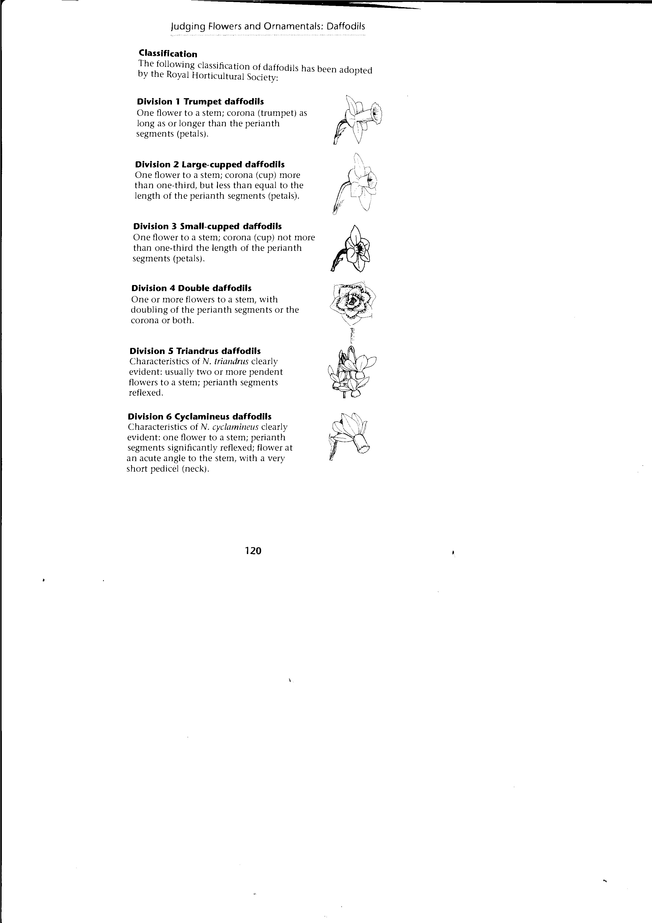

Spring Show Entry Form
No Entry Fee
Name (BLOCK CAPITALS please) ………………………………………………………………………
Address: ……………………………………………………………………………………………………………
Tel: ……………………………
I have read the rules on page 8 and undertake to comply with them

Signature: …………………………………………………………………………………

Rules for exhibition at the Spring Show

1. Entries must be made out on the form on page 7 and 8 and posted in the box provided in the foyer of the Community Club by 8pm on the THURSDAY preceeding the Show.
2. Entry cards must be collected from the Competition Secretary on the afternoon of the show between 12.30pm and 1.30pm and everything must be ready for the judge by 2pm.
3. The Show opens to the public at 3pm and closes at 5pm. No exhibits may be removed until that time.
4. All arrangements must be completed before placing on the show bench. ALL VASES MUST CONTAIN WATER and the stems of all the cut material must reach the water in the vase or other receptacle. The packing material used in vases, eg. soaked newspaper or ‘oasis’ should provide anchorage and allow the blooms to be shown to their best advantage.
5. Exhibits must be the property of the exhibitor and must have been in his or her possession for at least two months before the show.
6. Pot Plants must not have won prizes at any of the Society’s previous shows.
7. Exhibitors may enter up to TWO exhibits in each class but only the entry with the highest points will count towards the trophy.
8. Two or more persons may not exhibit separately in any class from the same garden.
9. The judge has the power to withhold or modify prizes where he/she considers the exhibits to be of insufficient merit. The judge’s decision as to the merit and the Committee’s decision as to the interpretation of the Schedule are final.
10. Each competitor’s points will be added towards prizes, which will be awarded at the end of the Show. In the event of a tie, the relevant award will be presented to the competitor who secures the greater number of 1st prizes in the class or classes concerned.
11. The Committee will not be responsible for any loss or damage to exhibits from whatever cause and all exhibits are shown at the sole risk of the competitor.
12. Entries will be judged in accordance with the RHS Horticultural Show Handbook 2016. A copy of this is held by the Competition Secretary.

NOTE: Late entries will be accepted on the Saturday of the Show, between 12.30pm and 1.30pm, with a Late Entry fee of 50p per entry.

SPRING SHOW 2023 ENTRY FORM

Please circle the class numbers for the classes you wish to enter. If you are entering more than one entry in a class please indicate this when you ring the class number.

1 2 3 4 5 6 7 8 9 10 11 12 13

14 15 16 17 18 19 20 21 22 23 24 25 26

Post this form in the Society’s box in the Community Club Foyer (High Street entrance) by 8pm on Thursday 13th April.

IFHS Coach Trip

RHS Wisley
Spring Craft and Design Show

Saturday April 29th

Cost £22 each, including drivers tip
Departing from The Bell at 9am, with pick ups at The Leas and The Plough in Mountnessing.
Return from Wisley at 4.30pm
Contact Ann Monk for any queries and to book a seat.
Phone:01277 352869 Email:anniemonk@talk21.com

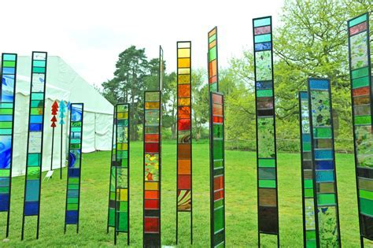

We are looking at a trip to Kew in September but as yet there are no details are available.
IFHS Outing

Visit an award winning garden in Chelmsford
A group visit to Sheila Chapman’s garden has been arranged on
28th June from 6.30-8.30pm 2023
Make your own way there, shared lifts can be aranged.
Cost £3.50 per person
Pre-booking and payment from May 1st 2023
Contact Helen Gillings -01277 353562

We are planning a trip to Cressing Temple Gardens in May. There will be a short talk about the history and types of plants in Tudor walled gardens. It will cost about £10 each and there is a Tiptree tearoom on site. More details will be available on our website and Facebook pages in due course.
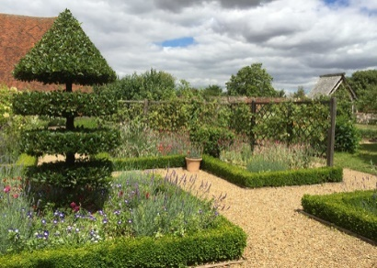
This Photo by Unknown Author is licensed under CC BY-NC-ND

The Big Seed Swap
March 15th 10am – 2pm
Community Corner, Chelmsford Indoor Market
A chance to make and meet gardening friends, take along your seeds, find seeds you need for your garden and get ready for the season ahead.
^{RHS HYDE HALL}
The IFHS is affilliated to the RHS and they allow us 2 cards which will grant the bearers a ⅓ discount on the price of entry to the gardens for non RHS members (members can enter free of charge).
If you would like to use these cards please contact Sarah Duke-Woolley – 07919447227 or sarah@beechamresearch.com and I will deliver them to you. They must be returned promptly after your visit. Events which may interest you :-

^{1-16th April} ^{The Giant Easter Egg Hunt}
^{22-23 April} ^{Spring Plant Fair}
^{28April – 1 May} ^{Craft & Design Show}
^{27 May – 4 June} ^{May Half Term – Sow Awesome}
^{23 – 25 June} ^{HydeHall Live}
^{30 June} Outdoor Theatre: Alice’s Adventures in Wonderland
^{2 July} ^{Classic Car Show}
^{14 July} Outdoor Theatre: Jane Austen’s Emma
^{2 – 6 August} RHS Garden Hyde Hall Flower Show
^{18 August} Outdoor Theatre: Comedy of Errors

Please note that there may be an extra charge for some of these events. For more details go to rhs.org.uk/gardens/hyde-hall/whats-on
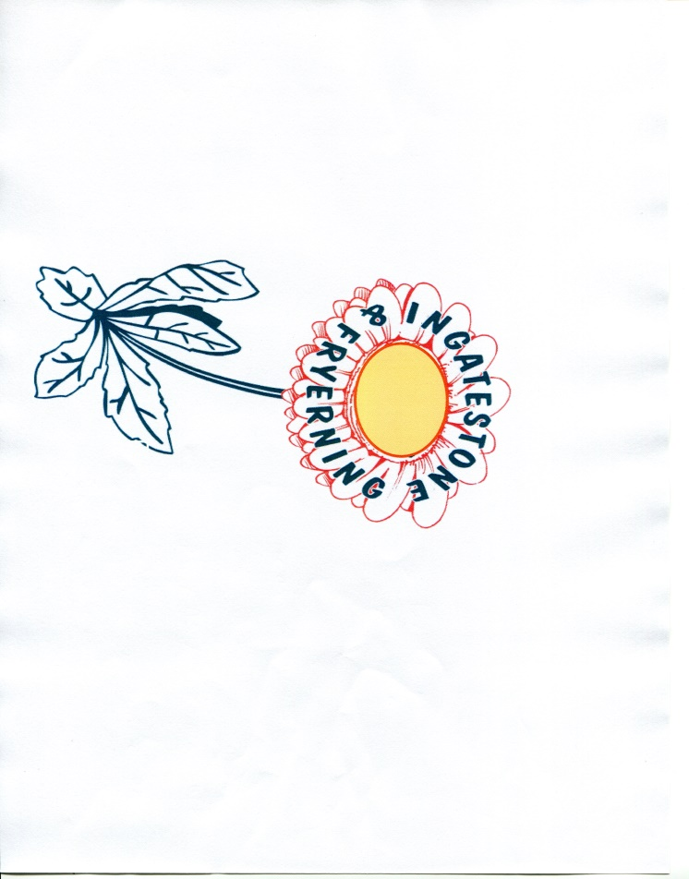
IFHS 2023
SUMMER SHOW
Saturday 15th July
CHECKLIST – SUMMER SHOW COMPETITORS
Monday 3rd to Monday 10th July All completed JUNIOR Entry Forms into the box at the Community Club no later than 8pm on Monday 11th July.
Monday 10th to Wednesday 12th July All completed ADULT Entry Forms into the box at the Community Club no later than 8pm on Wednesday 13th July.
Please note: Late entry fee of 50p will be charged for all entries received after the closing date/time.

Saturday 15th July 8am – 9.45am Competitors to collect their entry cards from the Secretarial Tent. No late entries after 9.15am. No exhibits after 9.45am. All staging to be completed by 10am when the tent closes for judging. See Rule 6, page 27.
For best results allow sufficient time for staging exhibits. Don’t forget plates/dishes for fruit, vegetables, cakes etc, and plastic bags, not cling film.

All exhibits are to remain in place until after the Prize giving.

Prize Money (children only) will be paid after 3.30pm.

All trophies to be handed back after Prize Giving for engraving.

IFHS 2023 Garden Competition
All gardens and commercial properties visible from the road in the Parishes of Ingatestone and Fryerning are eligible* for this competition.
A ‘short list’ is selected in June and all those on the list are advised before the judge visits in early July. Gardens are assessed according to the overall design, range of colour and on the visible amount of work the owner has contributed.

There are three categories:
- A Traditional (larger) Front Garden
- A Small Garden of courtyard proportions or one incorporating hard standing for vehicles
- Commercial properties
The results will be announced at the Summer Show. First prize winner in the Large Garden category will be awarded the Ronald Flack Memorial Trophy . First prize in the Small Garden category will be awarded a £10 National Garden Gift Voucher. Runners up in each category will receive a certificate.
First prize in Commercial properties will be awarded a certificate.
(*Winners in 2 previous years are not eligible in current year)
Anyone can nominate gardens to be considered – please contact Committee Member Helen Gillings – Tel:01277 353562.



Summer Show Schedule 2023
Saturday 15th July

Prizes will be presented at 5pm by the Chairman of Ingatestone & Fryerning Parish Council

JUDGES:
Horticulture: tba Art: tba
Soft Handicraft : tba Floral Art: tba
Hard Handicraft: tba Handwriting: tba
Domestic: tba Photography: tba

A NEW EXHIBITOR or NOVICE is welcome to enter every class.
Please mark your entry form with an ‘N’ in the class box. The John Ray trophy will be awarded to the new exhibitor with the most points.
A new exhibitor is one who has not previously won a first prize in either Horticulture, Domestic or Handicraft classes in any of our Horticultural Shows.

SCHEDULE OF CLASSES

HORTICULTURAL CLASSES

Lord Petre Challenge Cup: R.H.S. Banksian Medal

The RHS Banksian Medal is awarded to the highest number of place points in the whole of the Horticultural classes in the show.
Winner of the Banksian Medal in 2022 is not eligible in 2023.

Nora Pinnock memorial Trophy for the Best Exhibit in classes 1-34

Society £10 voucher for the highest points, excluding trophy winners.

Flowers

Christy Memorial Perpetual Challenge Cup
Class Points
- Flowers raised from seed in the last 12 months, one vase, one
kind only, not sweet peas …………………………………………. 4 3 2
2 Clematis, one or more varieties, three stems …………………… 4 3 2 3 Herbaceous Perennials, one vase, one kind only………………. 4 3 2
4 Herbaceous Perennials, one vase, more than one kind ……….. 4 3 2
5 Flowering Shrubs or Trees, one vase, one kind ………………… 4 3 2
6 Flowering Shrubs or Trees, one vase, more than one kind ……. 4 3 2
7 Mixed Garden Flowers, one vase, not less than three kinds ….. 4 3 2
9 Any shades of one colour flower, one vase, more than one kind. 4 3 2
Roses

Fieldgate Silver Challenge Cup
Skingley Medal for Best Rose Bloom

21 One Specimen Bloom, not miniature ……………………………… 4 3 2
23 Three Specimen Blooms, not miniature, one vase two or more
varieties ………………………………………………………………… 4 3 2
24 Three stems Cluster-flowered Roses, any type grown and shown
as cluster, one vase, one or more varieties …………………………. 4 3 2
25 Three stems Miniature Roses, all one variety ………………………. 4 3 2

Sweet Peas
Christy Memorial Trophy

31 Four stems, one vase, more than one variety ……………………… 4 3 2
32 Four stems, one vase, one variety only …………………………….. 4 3 2
33 Eight stems, one vase, more than one variety ……………………… 4 3 2
34 Two stems each of three distinct varieties, one vase ………………. 5 4 3

Pot Plants
Sidgwick Silver Challenge Cup

Plants must not have won prizes at any of the Society’s previous shows

43 Pot of Hostas, any variety, any number ……………………………… 4 3 2
44 One Fuchsia……………………………………………………………… 4 3 2
45 Any other pot plant in flower, one plant only………………………… 4 3 2
46 Any pot of Cactus or Succulent……………………………………….. 4 3 2
47 Any other pot plant grown for Foliage………………………………… 4 3 2

Fruit
Perpetual Silver Trophy

51 Blackcurrants, one plate, twelve strigs (bunches), one variety…… 4 3 2
52 Red or white currants, one plate, twelve strigs, one variety……… 4 3 2
53 Gooseberries, one plate, twelve fruits, one variety………………… 4 3 2
54 Raspberries, one plate, twelve fruits, one variety…………………… 4 3 2
55 *Any other kind of fruit, one plate, one variety……………………… 4 3 2
56 Collection of soft fruits, three distinct kinds, six fruits, strigs or
bunches of each……………………………………………………… 6 5 4
*See list on page 36
Vegetables

Norton Disney Challenge Trophy
Society £10 voucher for the runner up
Peter Baggot Memorial Trophy class 76

61 Lettuces, two, of one variety …………………………………………. 4 3 2 62 French Beans, six pods……………………………………………… 4 3 2 63 Mange-tout or Sugar Snap Peas, six pods of one variety…………. 4 3 2 66 Cucumbers, two………………………………………………………. 4 3 2 67 Peas, six pods ………………………………………………………. 4 3 2 68 Onions, four, as grown with roots and tops washed……………… 4 3 2 69 Beetroot, three……………………………………………………….. 4 3 2 70 Potatoes, any variety, four …………………………………………… 4 3 2 72 Rhubarb, four sticks ………………………………………………… 4 3 2
73 Courgettes, three …………………………………………………… 4 3 2 74 Tomatoes, four, one variety ………………………………………… 4 3 2
75 Any other vegetable, not listed in classes 61-74
see list on page 36 …………………………………………………… 4 3 2
76 Collection of vegetables, at least two of three or more kinds, must
be displayed in competitors own container ………………………… 8 6 4

Plant and Produce Stall
(in aid of Society Funds)

Contributions gratefully received on the day.
Please label your plants if possible.

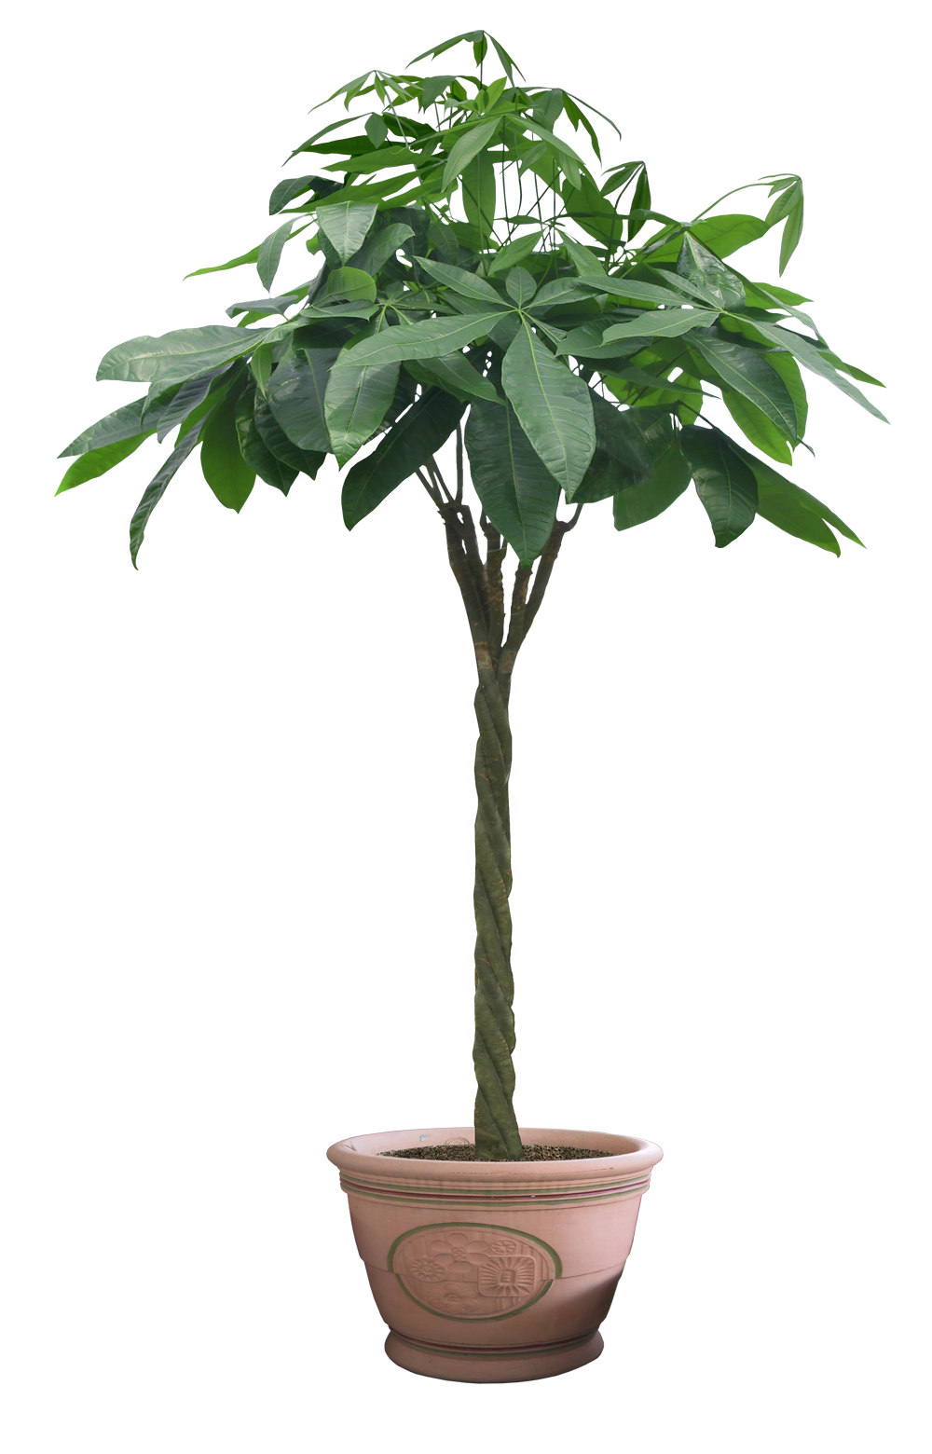

Handicraft Classes

Handicraft Classes
Georgian Silver Challenge Cup
Jocelyn Need Rose Bowl for Best Exhibit of Handicraft

Articles must not have been entered in any of the Society’s previous shows

101 Hand Knitted article……………………………………………………… 4 3 2
102 Embroidered article…………………………………………………..… 4 3 2
103 Accessory for the home, any material………………..……….... 4 3 2
104 Article of clothing, machine or hand sewn…………………….…….. 4 3 2
105 Bee in any medium, maximum size 30cm overall…………………. 4 3 2 107 Article of Handicraft, any soft material (not knitted)……………… 4 3 2
108 Article of Handicraft, hard material eg. pottery, woodwork…………. 4 3 2
109 Greetings card …………………………………………………….. 4 3 2
110 Quilt, any technique eg. patchwork or quilting……...……………..... 4 3 2
111 *Painting in Water Colours ……………………………………….……. 4 3 2
112 *Painting in any other medium …………………………….………..… 4 3 2
113 *Photograph of ‘Sun Rise ’or ‘Sunset’………………….……………… 4 3 2
114 *Photograph ‘A Flower’…………………………………….……… 4 3 2

*Please see notes for Exhibitors on page 40.

Domestic Classes
Silver Perpetual Trophy
Society Diplomas for highest points in classes 121- 125, 127-134, 137-140
Society’s Tankard for Best Exhibit in Classes 141 and 142

119 Honey, home produced, one jar………………………………………. 4 3 2
121 Strawberry Jam, new season, one jar…………………………………. 4 3 2
122 Raspberry Jam, new season, one jar………………………………….. 4 3 2
123 Any other Fruit Jam, one jar…………………………………..……….. 4 3 2
124 Marmalade, one jar………………………………………………………. 4 3 2
125 Fruit Jelly, one jar………………………………………………………… 4 3 2
127 *Ginger Cake……………………………………………….………… 10 8 6
128 *Victoria Sandwich, raspberry jam filling, no decoration ……….… 10 8 6
129 *Marmalade Cake…………………………………………………… 10 8 6
130 Flapjacks, plain, four………………………………………………….… 4 3 2
131 **Any cake including a vegetable eg. carrot, beetroot, courgette … 4 3 2
132 Gluten- free cake……………………………………………………… 4 3 2
134 Fruit Scones, four pieces………………………………………………. 4 3 2
137 Chutney or Pickle, one jar……………………………………………… 4 3 2
138 *Cheese Scones, four………………………………………………… 10 8 6
139 Biscuits for cheese, six…………………………………….………..… 4 3 2
140 Hand-made Bread Rolls, four…………………………………………… 4 3 2
141 Home-made Wine or Cordial, in a clear glass bottle……………... 4 3 2
142 Home-made Flavoured Gin or Vodka, in a clear glass bottle..…… 4 3 2

*Recipes on next page
**please label
Please note:
As baking tin dimensions vary according to the brand and material from which they are made sizes should be as close as possible to those stated in the recipe.
Refer to notes on page 40.

Ginger Cake: class 127
225g plain flour 110g butter
60g sugar 175g black treacle
1 level tsp bicarbonate of soda 60g golden syrup
1 tsp ground mixed spice scant 150ml milk
2 tsp ground ginger 1 egg

Pre-heat the oven to gas mark 2, 300°F, 150°C. Grease and line a 7” / 18cm square tin. Sift the dry ingredients into a large mixing bowl. Put butter, black treacle and golden syrup into a saucepan and heat until the butter melts, then cool and add to dry ingredients. Warm the milk in the saucepan to ensure none of treacle mixture is wasted. Pour into the mixing bowl and beat thoroughly. Lastly beat in the egg. Pour the mixture into the tin and bake in the centre of the oven for approximately 1½ hours. When done, allow to cool in the tin for 10 minutes before turning out onto a cooling rack. Store in an airtight tin for several days before cutting to allow the flavour to mature.

Victoria Sandwich: Class128

Three medium eggs
Weigh the eggs in their shells. Use this weight of butter, castor sugar and self-raising flour
1 tsp baking power
Some hot water, if necessary
Raspberry jam

Grease and line two 7 inch (18cm) sandwich tins. Preheat the oven to gas mark 3, 325°F, 170°C.
Cream together the sugar and butter to a pale fluffy mixture that drops from the spoon easily. Beat the eggs together thoroughly and then add, a little at a time to the sugar and butter mixture, beating the mixture well each time more egg is added. Add the baking powder to the flour and sift into the mixture. Fold in, using a metal spoon. You should have a soft dropping consistency. If necessary, loosen the mixture with a little hot water. Divide the mixture equally between the two tins and bake in the centre of the oven for 25 – 30 minutes .A skewer inserted into the middle of the cake should come out clean. Allow to cool in the tin for 1-2 minutes, then turn out and leave to cool completely on a wire rack.
When cool, sandwich together with raspberry jam. Do not decorate or dress with sugar.

Marmalade Cake: Class 129

115g soft margarine 2 large eggs
115g caster sugar 115g currants
175g self-raising flour 115g sultanas
40g glacé cherries, washed, dried and quartered
1 rounded tbsp chunky marmalade, chopped

Grease and line the bottom of a 2lb loaf tin. Pre-heat the oven to160°C, gas mark 3, 325°F
Measure the margarine, sugar, flour and eggs into a large bowl and mix together until blended. Stir in the marmalade, cherries, sultanas and currants. Turn the mixture into the tin and level the top. Bake for about 1¼ hours.

Ena’s Cheese Scones: Class 138

225g self-raising flour 55g margarine
Pinch of salt 75g finely grated cheese
1 rounded tsp. baking powder 6 -7 tablespoons milk
½ level teaspoon mustard powder milk or egg to glaze

Preheat the oven to 220˚C, 425˚F, gas mark 7.
Sieve all the dry ingredients together. Rub in the margarine to a breadcrumb consistency.
Stir in the grated cheese and mix with sufficient milk to form a soft but not sticky dough.
Knead lightly on a floured board and roll out to approximately ¾ inch / 2cm thick.
Cut with a plain round cutter, brush the tops with milk or beaten egg. A little extra grated cheese may be used for decoration, then bake for 12 – 15 minutes, until well risen and golden on top. Cool on a wire rack.

For Children’s Classes

This recipe is only a suggestion – if you have your own feel free to use it.

Salt Dough

1 cup of plain flour
½ cup of salt
½ cup water

Put the flour and salt into a mixing bowl. Slowly add the water. You may not need it all. Mix to soft but dry dough. Knead the dough until it is smooth, then use as required. Store in a plastic bag or cling film in the fridge to keep it fresh and stop it drying out. Once you have made your models, dry them in a low oven for *3 hours, taking care that they don’t brown or microwave for a total of about *3 minutes. After 2 minutes microwave for 10 seconds at a time until you judge they are done. When cool they can be painted.
*Timings will vary depending on the thickness of the dough, how wet /dry it is. Ovens and Microwaves also vary so try it out a few times before the show to avoid disappointment.

Handwriting Classes: 171, 181

How does the little busy bee
Improve each shining hour,
And gather honey all the day
From every opening flower
Isaac Watts
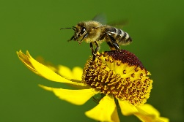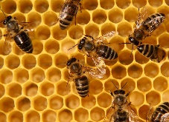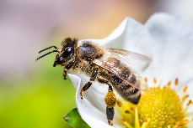
Children’s Classes
Edwina Lamb Trophy for Most Artistic Picture
Kari Best Trophy for Children’s Handicraft
Jack and Doris Nichols Cup for Children’s Horticulture

ALL FLOWERS TO BE ARRANGED BY THE CHILDREN THEMSELVES AND EXHIBITED IN THE VASES SUPPLIED unless stated otherwise.

In the Handwriting classes it is essential that the name should not appear on the exhibit.

To help the Judges, children are asked to note their age on all exhibits.
Articles must not have been entered in any of the society’s previous shows.

Children aged 5 and under – Certificate of Merit for all Entries
161 Salt dough model of a piece of fruit…………… …………………… 10 8 6
162 Collage picture a ‘Bee’ on A4 paper……….….………………… 10 8 6
163 Painting of the King, on A3 paper……….…………………………. 10 8 6

Children aged 7 and under – Holland Cup
Previous year’s winner not eligible in current year
169 Vase of mixed flowers and foliage, in society’s vase……………… 10 8 6
170 Mustard and cress, grown by exhibitor, see page 22 ……………. 10 8 6
171 Specimen of Handwriting ,Bee poem, above, A4…………….… 10 8 6
172 A decorated paper plate ……………… …………………………. 10 8 6
173 A card for the King’s coronation…… …………………………….. 10 8 6
174 Book cover for your favourite book, painted or drawn, A4……… 10 8 6
175 Collage, a ‘Bee’ on A4 paper………………………………………. 10 8 6
176 Painting of the King on A3 paper………………………..……….. 10 8 6

Children aged 9 and under -Edwina Lamb Challenge Cup
Previous year’s winner not eligible in current year
179 Vase of mixed flowers and foliage, in society’s vase……………… 10 8 6
180 Mustard and cress, grown by exhibitor, see page 22……………… 10 8 6
181 Specimen of Handwriting, bee poem, see page 20, A4…………… . 10 8 6
182 Article of hard material, eg wood, plastic, pottery, metal, not Lego 10 8 6
183 A decorated paper plate ……………..…………………………….… 10 8 6
184 A card for the King’s coronation……………………………………… 10 8 6
185 Landscape drawing, any medium, A4 ……………………………… 10 8 6
186 Book cover for your favourite book, painted or drawn, A4…………. 10 8 6
187 Painting of the King on A3 paper……………………… . ………….. 10 8 6

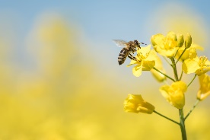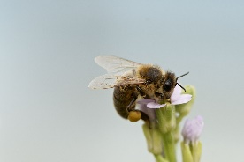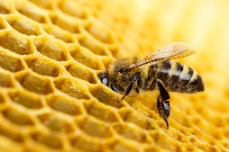

Children aged 12 and under – Carina Moss Cup
Previous year’s winner not eligible in current year
190 Floral arrangement in a mug ………………………………………….. 10 8 6
191 Any Verse, handwritten, on A4 plain paper…………….……… 10 8 6
192 Mustard and cress, grown by the exhibitor (see page 22)……… 10 8 6
193 Article of hard material, eg wood, metal, plastic, pottery, not Lego. 10 8 6
195 A card for the King’s coronation, ……….…..……………………. 10 8 6
196 Painting of the King, on A3 paper………………………………… 10 8 6
197 A decorated paper plate ……………..…………………………… 10 8 6
198 A close observational drawing of a natural object, any medium, A4.. 10 8 6
199 Photograph ‘An Animal’, see note below…………………………… 10 8 6

Young Person’s aged 13 to 18 years – Lady Jarratt Silver Challenge Cup
Previous winner not eligible in current year
205 Floral arrangement, in a mug …………………………………….….. 10 8 6
206 A portrait of the King, any medium, A4 ……………………………… 10 8 6
207 Photograph ‘An Animal’, see note below…………………………… 10 8 6
208 Homemade biscuits, any flavour, any shape, four……….………… 10 8 6

Note: Photographs should be no larger than A4 (30cm x 21cm) and may be mounted or framed if desired.

Growing a Tray of Mustard and/or Cress: Classes 170, 180, 192

Start about one week before the show.

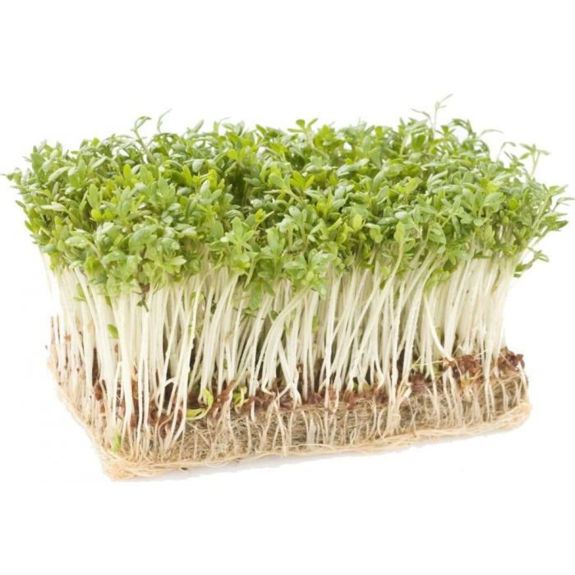
Line a plastic tray with several sheets of kitchen
paper and dampen it with water.
Scatter some mustard seeds over the damp paper. Place in a plastic bag and put somewhere warm and dark. After 3 days scatter the cress seeds over the same tray. Check frequently and water when necessary to ensure that the paper does not dry out but do not flood the tray. When the seeds start to germinate move them to a warm light place and remove the plastic bag.

Make a note of the date you start and inspect your seeds every day. Note when they germinate and start to grow.
The cress seeds will probably grow first and the mustard seeds may take a little longer.
Record how your seeds grow and how tall they get.
Bring your tray of mustard and cress to the show with your
notes.
Do not put your name on your tray or your record sheet

It is a good idea to sow two trays of seeds so that you can
choose the best to bring to the show

Vintage Car Display





SUMMER SHOW ADULT ENTRY FORM
Entry form should be completed on both sides and placed in a sealed envelope, with the appropriate fees, and placed in the box in the Community Club foyer, no later than 8pm on Wednesday 12th July 2023.

I / We have read the Rules and agree to abide by them.

Name /s: (Block Capitals) ……………………………………………………………………….

Signature /s ……………………………………………………………………………………….

Address: ……………………………………………………………………………………………

Tel. No.: ………………………………………….

Email: ……………………………………………………………………………………………….

If competing as a NEW EXHIBITOR or NOVICE in any class, please complete the following section:

I satisfy the conditions for competing as a novice.

Signed ………………………………………………… Date………………………………

SUMMER SHOW ADULT ENTRY FORM
Entry form should be completed on both sides and placed in a sealed envelope, with the appropriate fees, and placed in the box in the Community Club foyer, no later than 8pm on Wednesday 12th July 2023.

I / We have read the Rules and agree to abide by them.

Name /s: (Block Capitals) ……………………………………………………………………….

Signature /s ……………………………………………………………………………………….

Address: ……………………………………………………………………………………………

Tel. No.: ………………………………………….

Email: ………………………………………………………………………………………………..

If competing as a NEW EXHIBITOR or NOVICE in any class, please complete the following section:

I satisfy the conditions for competing as a novice.

Signed ………………………………………………… Date…………………………
SUMMER SHOW ADULT ENTRY FORM
No Entry Fee
Circle the number of the class for which entry is intended.
Write ‘N’ if entering the class as a Novice.

1 | 2 | 3 | 4 | 5 | 6 | 7 |  | 9
21 |  | 23 | 24 | 25 |  | 31 | 32 | 33 | 34
 | 43 | 44 | 45 | 46 | 47 |  |  |  |  | 51 | 52
53 | 54 | 55 | 56 |  | 61 | 62 | 63 |  |  | 66 | 67
68 | 69 | 70 |  | 72 | 73 | 74 | 75 | 76
101 | 102 | 103 | 104 | 105 |  | 107 | 108 | 109 | 110 | 111 | 112
113 | 114 |  | 119 |  | 121 | 122 | 123 | 124 | 125 |  | 127
128 | 129 | 130 | 131 | 132 |  | 134 |  |  | 137 | 138 | 139
140 | 141 | 142

SUMMER SHOW ADULT ENTRY FORM
No Entry Fee
Circle the number of the class for which entry is intended.
Write ‘N’ if entering the class as a Novice

1 | 2 | 3 | 4 | 5 | 6 | 7 |  | 9
21 |  | 23 | 24 | 25 |  | 31 | 32 | 33 | 34
 | 43 | 44 | 45 | 46 | 47 |  |  |  |  | 51 | 52
53 | 54 | 55 | 56 |  | 61 | 62 | 63 |  |  | 66 | 67
68 | 69 | 70 |  | 72 | 73 | 74 | 75 | 76
101 | 102 | 103 | 104 | 105 |  | 107 | 108 | 109 | 110 | 111 | 112
113 | 114 |  | 119 |  | 121 | 122 | 123 | 124 | 125 |  | 127
128 | 129 | 130 | 131 | 132 |  | 134 |  |  | 137 | 138 | 139
140 | 141 | 142

SUMMER SHOW: CHILDREN’S ENTRY FORM (one form per child)
Complete both sides and place in the box in the Community Club foyer by
8pm on Monday 10th July 2023
I have read the Rules and agree to abide by them

Name (Block Capitals) ………………………………………………………………………….

Signature ………………………………………………………… Age …………………………..

Address …………………………………………………………………………………………….

Reminder: to assist the judges, children are asked to note their age visibly on all exhibits.

………………………………………………………………………………………………cut here

SUMMER SHOW: CHILDREN’S ENTRY FORM (one form per child)
Complete both sides and place in the box in the Community Club foyer by
8pm on Monday 10th July 2023
I have read the Rules and agree to abide by them

Name (Block Capitals) ………………………………………………………………………….

Signature ………………………………………………………… Age …………………………..

Address …………………………………………………………………………………………….

Reminder: to assist the judges, children are asked to note their age visibly on all exhibits.

………………………………………………………………………………………………cut here

SUMMER SHOW: CHILDREN’S ENTRY FORM (one form per child)
Complete both sides and place in the box in the Community Club foyer by
8pm on Monday 10th July 2023
I have read the Rules and agree to abide by them

Name (Block Capitals) ………………………………………………………………………….

Signature ………………………………………………………… Age …………………………..

Address …………………………………………………………………………………………….

Reminder: to assist the judges, children are asked to note their age visibly on all exhibits.

CHILDREN’S ENTRY FORM: NO ENTRY FEE
Circle the class numbers you are entering, one entry per class.

161 | 162 | 163 | 169 | 170 | 171 | 172 | 173 | 174 | 175 | 176
 |  | 179 | 180 | 181 | 182 | 183 | 184 | 185 | 186 | 187
 |  |  | 190 | 191 | 192 | 193 |  | 195 | 196 | 197
198 | 199 |  |  |  |  | 205 | 206 | 207 | 208

CHILDREN’S ENTRY FORM: NO ENTRY FEE
Circle the class numbers you are entering, one entry per class.

161 | 162 | 163 | 169 | 170 | 171 | 172 | 173 | 174 | 175 | 176
 |  | 179 | 180 | 181 | 182 | 183 | 184 | 185 | 186 | 187
 |  |  | 190 | 191 | 192 | 193 |  | 195 | 196 | 197
198 | 199 |  |  |  |  | 205 | 206 | 207 | 208

CHILDREN’S ENTRY FORM: NO ENTRY FEE
Circle the class numbers you are entering, one entry per class.

161 | 162 | 163 | 169 | 170 | 171 | 172 | 173 | 174 | 175 | 176
 |  | 179 | 180 | 181 | 182 | 183 | 184 | 185 | 186 | 187
 |  |  | 190 | 191 | 192 | 193 |  | 195 | 196 | 197
198 | 199 |  |  |  |  | 205 | 206 | 207 | 208

RULES FOR EXHIBITION AT THE SUMMER SHOW

- Acceptance of entries: the Committee reserves the right to refuse any entry and, in the event of such a refusal, it is not required to give any reason or explanation.

- Exhibits must be the property of the exhibitor: all exhibits in competition must be the property of the person in whose name they are entered, and must have been grown from seed or been in his / her possession or cared for by him / her for at least three months before the show. The Committee reserves the right to examine the garden, glass house or allotment of any exhibitor, either before or after the show. Flowers in classes 169, 179, 190 and 205 need not have been grown by the exhibitor.

- Number of entries per household: two or more persons may not exhibit separately in any one class from the same garden, glass house or allotment. If members of a household wish to share the credit / prizes the exhibit should be entered in joint names.

- Multiple entries: no exhibitor may enter more than one exhibit in any one class.

- Procedure for submitting entries: exhibitors must give notice of the classes in which they intend to compete on the official form provided in the Handbook by the dates shown on the entry form. A late entry fee of 50p will be made on all entries received after the closing deadline.

- Staging entries: entry cards may be collected from 8.00am from the Secretary’s tent on the Showground. These cards must be placed in front of their respective exhibits in the correct classes with the side showing the entrant’s name and address downwards. All exhibits of flowers must be staged in the vases provided unless otherwise stated and the arrangement completed before staging on the show bench. All stems must reach the water in the vase and all vases must contain water, not just damp oasis.
- No late entries will be accepted after 9.15am and NO EXHIBITS will be accepted or staged on the day of the show after 9.45am.
- All exhibits must be ready by 10am when the tent will be closed for judging.
- All exhibitors must leave the tent during judging.
- No exhibits may be touched by the anyone until the time for their removal which is after the prize giving.
- The tent will be closed during the presentation of awards, no exhibits may be removed during that time.

Exhibitors must remove all exhibits and empty and return all vases when the tent is opened after prize giving.

- Constitution of an exhibit: where a number or quantity of plants, flowers, fruit or vegetables is specified for any class ANY EXCESS OR DEFICIENCY IN NUMBER DISQUALIFIES THE EXHIBIT. If any excess or deficiency is noticed before judging takes place, the steward or the secretary may give the exhibitor (if at hand) an opportunity to correct the mistake or correct it himself. Judges may not correct any error but they may bring it to the attention of a steward or the secretary for correction if possible. Fruit and vegetable exhibits, unless otherwise stated, must consist of one variety only.

- Prizes: The number of points awarded for 1st, 2nd and 3rd prizes is indicated against each class in the Schedule. Each competitor’s points are added towards a trophy or diploma. In the event of a tie, the relevant award will be presented to the competitor who secures the greatest number of 1st prizes in the section concerned.

- IN THE SUMMER SHOW, IN CHILDREN’S CLASSES ONLY, EACH POINT REPRESENTS 10p IN PRIZE MONEY. All prize money will be paid out during the afternoon of the show after 3.30pm. Other than specified, no prize money is awarded in adult classes.

- Prizes may be withheld or modified if the exhibits are considered unworthy of the prize offered.

- Decisions: The decision of the judges on all points relative to the merits of exhibits, and that of the Committee as to the interpretation of the Schedule rules is final. Any protest must be made in writing and delivered to the Secretary on the day of the show.

- Liability for loss: all exhibits, personal property, etc., will be at the risk of the exhibitors and the Society and Committee will not be liable for compensation for loss or damage from any cause whatsoever. Should a show for any cause not be held, or the date changed, no exhibitor will have a claim on the Society.

- Entries will be judged in accordance with guidelines in the RHS Horticultural Show Handbook 2016. This Handbook is held by the Competition Secretary.

- Eligibility of exhibitors: on all questions regarding the eligibility of an exhibitor the decision of the Committee is final.

Exhibitors should also refer to the guidance notes on pages 37 to 40

DOG SHOW

This is an informal, fun show
Register your dog on arrival by 1.30pm

There will be a number of classes including
The waggiest tail
The best four legs
The most handsome dog
The prettiest bitch



Autumn Show Schedule 2023
Saturday 23rd September

Community Club, Ingatestone 3-5pm
Prizes will be presented at 4.30pm by tbc

Judge: Gill Owen

A NEW EXHIBITOR or NOVICE is welcome to enter every class.
Please mark your entry form with an ‘N’ in the class box as there will be a diploma awarded to the new exhibitor with the most points.
A new exhibitor is one who has not previously won first prize in either Horticulture, Domestic or Handicraft in any of our horticultural shows.

SCHEDULE OF CLASSES
HORTICULTURAL CLASSES

Skingley Medal for Best Exhibit in Show
Two £5 prizes for Highest Points excluding Trophy winners

(In classes 301 – 338 the number of flowers or stems stated should be exhibited in one vase)
Roses
P. J. Davy Perpetual Challenge Cup
A. W. D. Nicholls Memorial Cup for Best Bloom

Class Points
301 One Specimen Bloom, not miniature…..………………………… 4 3 2
302 One Rose, to be judged on scent alone…………………………. 4 3 2
303 Three Specimen Blooms, any one variety ………………………. 4 3 2
304 Three stems Cluster-Flowered Roses (any type grown and
shown as cluster) one or more varieties………………………. …….. .4 3 2

Dahlias
Beresford Kneller Trophy

(Dalhias in classes 321,322 and 323 should be decorative, cactus or semi- cactus)

321 Medium, one bloom, 150mm – 200mm diameter…………….…..…. 4 3 2
322 Small, one bloom, 100mm – 150mm diameter …………………….. 4 3 2
323 Miniature, one bloom, not to exceed 100mm ………………………. 4 3 2
324 One bloom, ball 50mm-150mm, or pompon less than 75mm……. 4 3 2
325 Three Dahlias of the same variety, any size………………………… 4 3 2
326 Three Dahlias, two or three varieties, any size ……………………… 4 3 2
327 Any Dahlia not included in the above classes, one bloom ….. ………4 3 2
328 Mixed Dahlias displayed for effect, one vase…………………………..4 3 2
Flowers
A.Pudney Perpetual Cup
331 Fuchsia, one specimen bloom, to be staged in competitor’s own
plain, colourless glass ………………………………………………… 4 3 2
332 Flowers grown from seed in the current year, one kind only ……… 4 3 2
334 Hydrangea, one stem, any variety ……………………………………. 4 3 2
335 Herbaceous Perennial, one kind, not Dahlias ……………………….. 4 3 2
336 Herbaceous Perennial, more than one kind, not Dahlias …………… 4 3 2
337 Vase of Mixed Garden Flowers, not less than three kinds ……….. 4 3 2
338 Vase of Autumnal Foliage and / or fruits and berries ……………… 4 3 2

Pot Plants
H.J. Loker Perpetual Cup
(Plants must not have won prizes at any of the Society’s other shows)
342 Any Pot Plant grown for flowers or foliage ………………………….. 4 3 2
343 One Pot of Cactus……………………………………………………… 4 3 2
344 One Pot of Succulent ………………………………………………….. 4 3 2
345 Pot grown Vegetable, shown in pot …………………………………… 4 3 2

Fruit
J. Roper Perpetual Challenge Cup
351 Apples, Dessert, one variety, dish of four ..…………………………. 4 3 2
352 Apples, Culinary, one variety, dish of four……….…………………… 4 3 2
353 Pears, Dessert or Culinary, one variety, dish of four ……………….. 4 3 2
355 *Any other kind of fruit …………………………………………………. 4 3 2
*See list on page 36

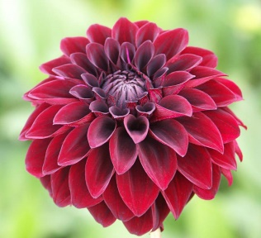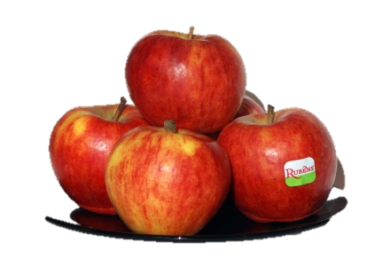

Vegetables
J. Miles Perpetual Challenge Cup
361 Potatoes, one variety, four …………………………………………… 4 3 2
362 Carrots, one variety, three ……………………………………………. 4 3 2
363 Onions, one variety, four …………………………… ……………… 4 3 2
364 Runner beans, one variety, six pods ………………………………… 4 3 2
365 French Beans, one variety, six pods…………………………………. 4 3 2
366 Chard or Spinach, 6 stems displayed in water in a clear glass
container…………………………………………………………………. 4 3 2
367 Pumpkin or squash, one ……………………………………………… 4 3 2
368 Beetroot, one variety, three …………………………………………… 4 3 2
370 Tomatoes, small or cherry variety, dish of four, max 35mm diam.… 4 3 2
371 Tomatoes, any other variety, dish of four ……………………………. 4 3 2
372 A Truss of Tomatoes, (do not all need to be ripe) …………………… 4 3 2
374 Peppers, chilli, one variety, six ……………………………………….. 4 3 2
376 Any other vegetable, not listed above, see List on page 36 …… 4 3 2
377 Any vegetable to be judged on its length……………………………….4 3 2

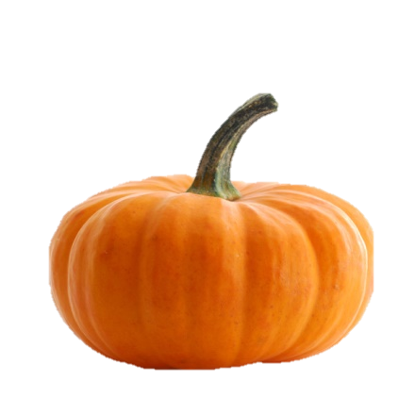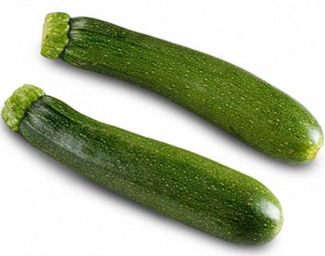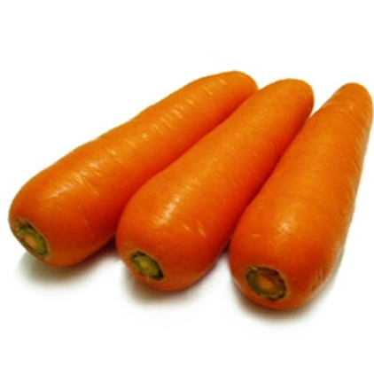

AUTUMN SHOW ENTRY FORM

(complete both sides of form)

Completed form to be placed in the box in the Community Club foyer no later than 8pm on Wednesday 20th September 2023

I / We have read the rules (see page 35) and agree to abide by them.

Name /s: ……………………………………………………………………………………………

Signed: ……………………………………………………………………………………………..

Address: ……………………………………………………………………………………………

Tel. No. ………………………………… (adults only)

Email: ……………………………………………………………………………………………….

If competing as a NEW EXHIBITOR or NOVICE in any class, please complete the following section:

I satisfy the conditions for competing as a novice.

Signed ………………………………………………… Date………………………………

AUTUMN SHOW ENTRY FORM
(complete both sides of form)

Completed form to be placed in the box in the Community Club foyer no later than 8pm on Wednesday 20th September 2023

I / We have read the rules (see page 35) and agree to abide by them.

Name /s: ……………………………………………………………………………………………

Signed: ……………………………………………………………………………………………..

Address: ……………………………………………………………………………………………

Tel. No. ………………………………… (adults only)

Email: ……………………………………………………………………………………………….

If competing as a NEW EXHIBITOR or NOVICE in any class, please complete the following section:

I satisfy the conditions for competing as a novice.

Signed ………………………………………………… Date……………………………
AUTUMN SHOW ENTRY FORM

Circle the class for which entries are intended.
If entering as a Novice write ‘N’ in the relevant square.
If you are making more than one entry in a class, state the number of entries in the TOP LEFT CORNER of the relevant square.

301 | 302 | 303 | 304 |  | 321 | 322 | 323 | 324 | 325 | 326
327 | 328 | 331 | 332 |  | 334 | 335 | 336 | 337 | 338
 | 342 | 343 | 344 | 345 |  | 351 | 352 | 353 |  | 355
361 | 362 | 363 | 364 | 365 | 366 | 367 | 368 |  | 370 | 371
372 |  | 374 |  | 376 | 377

AUTUMN SHOW ENTRY FORM

Circle the class for which entries are intended.
If entering as a Novice write ‘N’ in the relevant square.
If you are making more than one entry in a class, state the number of entries in the TOP LEFT CORNER of the relevant square.

301 | 302 | 303 | 304 |  | 321 | 322 | 323 | 324 | 325 | 326
327 | 328 | 331 | 332 |  | 334 | 335 | 336 | 337 | 338
 | 342 | 343 | 344 | 345 |  | 351 | 352 | 353 |  | 355
361 | 362 | 363 | 364 | 365 | 366 | 367 | 368 |  | 370 | 371
372 |  | 374 |  | 376 | 377

RULES FOR EXHIBITION AT THE AUTUMN SHOW

The Rules for the Summer Show numbered 1, 2, 3, 5, 7, 8, 10, 11, 12, 13 and 14 also apply to this Show.

Additional Specific Rules for the Autumn are as follows:

4-AS Two entries per class are allowed for this show, only the prize with the highest points will be added to that competitor’s trophy points.

6-AS Staging entries: entry cards should be collected from the Secretary’s table in the Club Hall between 12 and 1.15pm on the afternoon of the Show. These cards must be placed in front of their respective exhibits in the correct classes with the side showing the entrant’s name and address downwards. All exhibits of flowers must be staged in the vases provided unless stated otherwise and all arrangements completed before staging on the show bench. All stems must reach the water and all vases must contain water, not just damp oasis.

No late entries will be accepted after 1pm. Everything must be ready for the judge by 2pm when the hall will be closed for judging. No exhibit may be removed until after prize giving then exhibitors must remove all exhibits and return all vases..

Exhibitors should also refer to the guidance notes on pages 37 - 40.

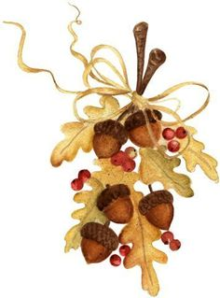

Any Other Vegetable – Number of specimens required
Applies to Summer Show Class 75 and Autumn Show Class 376

Artichoke, globe | 2 |  | Onions, green salad | 6
Artichoke, Jerusalem | 6 |  | Oriental Brassicas, flower stalks | 6
Asparagus | 6 |  | Oriental Brassicas, heading types | 2
Asparagus peas, pod | 6 |  | Oriental Brassicas, loose leaved | 2
Aubergines | 2 |  | Parsnips | 3
Beans, broad, pods | 6 |  | Peas, pods | 6
Beans, runner, pods | 6 |  | Peas, mange-tout, sugar snap | 6
Broccoli, coloured heads | 2 |  | Peppers, hot (chilli) | 6
Broccoli, sprouting (shoots) | 6 |  | Peppers, sweet | 3
Brussels Sprouts | 6 |  | Pumpkin | 1
Cabbages, Chinese | 2 |  | Radish, oriental, winter | 3
Cabbages, green, red, savoy | 2 |  | Radish, small, salad | 6
Calabrese Heads | 2 |  | Rhubarb | 4
Carrots | 3 |  | Salsify | 2
Cauliflower | 2 |  | Scorzonera | 2
Celery | 2 |  | Shallots | 6
Celeriac | 2 |  | Spinach, beet and chard leaves | 6
Courgettes | 3 |  | Spinach, New Zealand, tips | 6
Cucumbers | 2 |  | Squash, summer | 2
Fennel, Florence | 2 |  | Squash, winter | 2
Garlic | 3 |  | Swedes | 2
Kale leaves | 6 |  | Sweetcorn | 2
Kohlrabi | 3 |  | Turnips | 3
Leeks | 3
Lettuces,all types | 2
Marrows | 2

Any Other Fruit – Number of Specimens required
Applies to Summer Show class 55 and Autumn Show Class 355

Apricots | 4 |  | Lemons, other Citrus | 2
Blackberries | 12 |  | Melon | 1
Blueberries | 20 |  | Mulberries | 12
Cherries | 12 |  | Nectarines or Peaches, each type | 4
Damsons | 6 |  | Plums | 4
Figs | 3 |  | Quinces | 3
Grapes, bunch | 1 |  | Raspberries | 12
Greengages | 4 |  | Strawberries | 8
Hybrid cane fruit eg. Logan berry | 12 |  | Strawberries, alpine | 12
Jostaberries, strigs | 12 |  | Worcesterberries, strigs | 12

NOTES FOR EXHIBITORS
These notes should be used in conjunction with the RULES FOR EXHIBITION.
If you have any queries please contact the Competition Secretary.

The words “KIND” and “VARIETY” are used in the following sense: Roses, Sweet Peas and Dahlias are KINDS of flower; Crimson Glory, Ena Harkness and Peace are VARIETIES or CULTIVARS of Roses.

PREPARATION and PRESENTATION of produce at shows:
All exhibits should be staged as attractively as possible in accordance with the rules and the schedule. If the judging is close, arrangement may be the deciding factor. Always take a few extra specimens to the show in case of accident and before leaving the show bench check the correct number have been staged so that your exhibit is not marked ‘NAS’ (Not According to Schedule).

PLANT LABELS:
The interest in a show is much enhanced if plant material is labelled with both kind and variety. Labels should be clearly written on cards measuring approx. 5cm x 7.5 cm in size, a supply of which will be available on the day of the show.

FLOWERS:
- Floral exhibits are judged on condition, uniformity, and attractiveness of presentation. Material should be fresh and free from damage and disease. The specimens in an exhibit should be alike in age, size and form. They should be arranged to display their merits to best advantage.
- Any type of flower grown from seed in the last twelve months can be exhibited in the appropriate classes; this includes perennials.
- All vases must contain sufficient water to last for the duration of the show. Exhibitors must provide their own plant support material (oasis, paper) for the regulation vases which are supplied by the society.
- Material for a show is best cut in the evening or early morning when flowers and foliage are cool. The cut stems should be stood in deep water. It is advantageous to leave them overnight in a cool place from which light is mostly excluded to prevent the stems curving towards the light. Exhibits are judged on their appearance at the time of judging.

ROSES: Any type of modern rose can be exhibited in any class.

POT PLANTS:
- Pots or containers should be clean and undamaged. Where staking, tying or wiring is necessary, it should be done neatly and not detract from the appearance of the plant. Plants should be clean, healthy and unblemished.
- Plants with brightly coloured bracts are considered to be flowering plants for show purposes, eg. Bougainvillea, Beloperone.
- Cuttings, bulbs, tubers or corms normally grown more than one to a pot to give a full appearance, eg. Tradescantia, Achimenes or Freesia, are admissible as “one plant” even though there is more than one plant in the container.
- If a plant grown for foliage is in flower at the time of the show, it may still be entered in the foliage class, where no account will be taken of the flowers. If the flowers merit it, the same plant may alternatively be entered in a flowering pot plant class.
- Ferns, Bromeliads, Orchids and similar epiphytic plants may be shown attached to a piece of bark or wood instead of in pots.

FRUIT:
The specimens composing an entry should be uniform in size, condition, form and colour, of one variety/cultivar only and all with stalks intact. Handle all fruits as little as possible and by their stalks where possible to preserve their natural bloom. Use scissors rather than fingers to remove soft fruits. Pick more than necessary so that reserves are available when staging. Where possible, specimens should be arranged on a dish or plate. Judges may cut fruit.
Apples: should not be polished and should be staged with stalk end downwards.
Berries: best exhibited placed in lines so they can be easily counted. Stalks and calyces should be fresh and all point one way.
Currants: the strigs should be intact and laid roughly parallel, the bottom of the strigs to the front of the plate.
Grapes: should be shown as a complete bunch, with a piece of lateral shoot on either side of the stalk to form a T-handle.
Jostaberries, Worcesterberries and Blueberries: should be laid roughly parallel where possible.
Melons: should be shown with a T-handle, as for grapes.
Pears, Quinces and Figs: best arranged around the perimeter of the plate with the stalks facing towards the centre. Figs with signs of splitting can be exhibited as this is a sign of ripeness.
Plums, Cherries and similar shaped fruits: best laid out in lines across the plate. The bloom should not be disturbed and stalks should be intact. Gages with signs of slight shrivelling can be exhibited as this is a sign of ripeness.

HERBS: should be shown not in flower. Lavender is not a herb.

VEGETABLES:
- The specimens composing an entry should be uniform in size, condition, form and colour, and of one variety/cultivar only.
- Where necessary, vegetables should be carefully washed to remove soil. In no circumstances should substances be applied to enhance their appearance. Wash with a soft cloth and plenty of water; brushing will damage the skin. On other kinds retain the natural bloom wherever possible. Water all vegetables before harvesting and handle carefully during preparation.
- Stage as attractively as possible on dishes, plates or directly on the table in a wheel formation eg peas; in a row eg. runner beans; or in a pyramid eg. carrots.
- Exhibitors should be aware that certain root vegetables may be cut by the judge.
Beetroot: select roots of even size; for globe beetroot, for long beetroot; and for cylindrical roots. Small side shoots should be removed. Take care in washing as all marks will show up clearly after a few hours. Trim foliage to approx. 75mm
Beans, broad, French and runner: cut all pods from the vine using scissors and ensure each pod has a portion of stalk. Stage on a dish or plate or directly in the bench; stalks at one end. In the class for French beans, a climbing or dwarf variety may be exhibited. Judges will determine freshness by snapping or opening a pod.
Cabbages: clean, fresh, solid heads of equal size, with a good waxy bloom and free of pest damage. Remove the minimum of outer discoloured leaves. Stage with approx. 75mm of stalk remaining, heads to the front.
Carrots: firm, fresh, blemish free specimens of good colour and uniformity without discolouration at the top. Cut off foliage to approx. 75mm.
Cauliflowers, Calabrese and Broccoli: stage with approx. 75mm of stalk remaining. Just prior to staging trim back leaves to match the level of the outside of the curd.
Courgettes: young, tender, shapely fruits approx. 150mm in length and 25- 35mm in diameter, or in the case of round cultivars approx. 75mm in diameter. Stage with or without the flowers still adhering.
Cucumbers: should be well matched, straight and of a good, fresh green colour with 3cm of stalk. It is not necessary that flowers remain attached.
Lettuce: lift with roots intact in evening or early morning. Fresh, uniform heads of attractive colour are essential. Roots should be washed, wrapped in moist tissue, inserted in a plastic bag and neatly tied. Remove only markedly damaged outer leaves, stage on show bench with heads facing front.
Marrows: tender, young, uniform fruits are most desirable, which should be less than 350mm long. Wipe clean and stage directly on the show bench.
Onions avoid soft, stained specimens with thick immature necks. Do not over skin. In the Autumn Show, the tops should be tied or whipped using plain raffia and the roots neatly trimmed back to the basal plate. Onions are often staged on rings or soft collars. Pickling onions must not exceed 30mm in diameter nor should necks be tied or whipped.
Onions, green salad: plants should be staged with foliage and roots attached and well washed.
Oriental Brassicas, heading types: specimens of equal size, fresh, clean and with good bloom. Display with roots intact, well washed, wrapped in moist tissue, inserted in a plastic bag and neatly tied.
Parsnips: should be straight and of a good length, evenly tapered and well developed. Great care should be taken when lifting the roots, as bruising by fingers and scratching by soil particles will show later. Water well before lifting, wash carefully and cut off foliage to approx. 75mm.
Peas: the pods should be uniform in length and in good condition. Judges will open and check pods during their examination. Cut pods from the vine with scissors, retaining 25mm of stalk and handle by this stalk to retain the natural bloom. Holding pods up to a strong light will detect internal damage and reveal the number of peas.
Peppers, sweet and hot (chilli): may be shown immature but fully formed, green, or at the mature or coloured form. The exhibit should be fresh and uniform in colour.
Potatoes: select medium sized specimens, generally between 200g and 250g. Select equally matched tubers with shallow eyes and free from skin blemishes. Wash carefully with a soft sponge in clean water. Stage on a dish or plate with ‘rose’ end pointing outwards.
Radishes, small salad: fresh, firm, medium-sized, young, tender and brightly coloured specimens. Trim foliage to approx. 30mm.
Rhubarb: trim top foliage off leaving approx. 75mm from start of leaf stalks. Wipe stalks clean and trim off any bud scales at the bottom.
Shallots: should be shown as separate bulbs on dry sand. Tops and roots should be trimmed.
Spinach, Spinach Beet, Chards: large, fresh, thick, undamaged leaves are required with a neatly trimmed stalk. Present in water in a clear glass container.
Squashes: blemish free, with stalk attached.
Sweetcorn: cobs of uniform size and fresh green husks should be displayed with approximately one quarter of the grain exposed by pulling down sharply from the tip to the base and removing several husks. The stalks should be trimmed.
Tomatoes: should be ripe, firm, well-shaped and well coloured with the green calyx (stalk) attached. Stage on a plate or dish, calyx uppermost.
Turnips and Swedes: solid, shapely roots with small tap root and no side shoots.

HANDICRAFT:
- If a large item is being entered, eg a quilt or a rug, please indicate on the entry form.
- Entries in classes 111 and 112 should be prepared with cord, ready for hanging. Signatures on all items should be covered.
- Photographs should measure not more than A4 (30cm x 21cm) mounted and /or framed if desired.

PRESERVES, WINES, CORDIALS, etc:
- Jars and bottles should be clean and unblemished, made of clear glass and free from all commercial/trademarks, whether on the lid, jar or base, otherwise they may be eliminated. A wax disc is not required with a twist top. Vinegar preserves require a lid which is not liable to corrosion; cellophane covers should not be used for pickles or chutney. Preserves need to be filled to within 3mm of the top of the jar. Chutney needs to mature and must be at least 3 months old before showing.
- All jars should be labelled to show the date and type of preserve, with the label affixed towards the bottom of the jar. Labels will be provided, bearing the entrants number which must also be affixed to each of their jars.
- Wines, Spirits and Cordials should be exhibited in clear, colourless glass bottles. All wines, cordials etc. should bear a label describing the contents eg. Parsnip Wine - dry, Elderflower Cordial.

BAKING:
- Cakes should be presented on a plate (not paper) with a doily. Bread may be presented on a breadboard or a flat plate. Savouries may be garnished.
- Packet mixes and ready–made pastry are not allowed.
- Each domestic exhibit, except those in jars or bottles, must be placed in a large plastic bag. Please do not use cling film as it is hard to replace properly after the judging.
- The temperatures of appliances vary, and it is recommended that new recipes are tried out beforehand.

IFHS PRIZE WINNERS 2022
SPRING SHOW
Pilling Dunn Cup – Highest points in show Janet Collins
Second Highest Points Anne Oxley
Third Highest Points John Saxton
Ethel Ellis Memorial Challenge Cup for best exhibit Anne Oxley
Trevor Cracknell Trophy for best daffodil Thomas Carpenter

SUMMER SHOW 2022

Horticultural Classes
Lord Petre Challenge Cup, Open Horticulture Jacqueline Lewis
RHS Banksian Medal – Highest Points in Horticulture Classes Jacqueline Lewis
Christy Memorial Perpetual Challenge Cup for Flowers Jacqueline Lewis
Fieldgate Silver Challenge Cup for Roses Jacqueline Lewis
Skingley Medal for Best Rose Bloom Jacqueline Lewis
Christy Memorial Trophy for Sweet Peas John Bassom
Nora Pinnock Memorial Trophy Jacqueline Lewis
Sidgewick Silver Challenge Cup for Pot Plants Sarah Duke-Woolley
Perpetual Silver Trophy for Fruit John Saxton
Norton Disney Challenge Trophy for Vegetables John Walker
Society Gift Voucher (£10) Runner-Up: Flower Classes Betty Callaghan
Society Gift Voucher (£10) Runner-Up: Vegetable Classes John Saxton

Annual Garden Competition
Ronald Flack Memorial Trophy, Best Large Garden Mr James
Large Garden Runner-Up Mr and Mrs Gooding
Award for Best Small Garden Lara St Pierre
Small Garden Runner-Up Mr and Mrs McNeil
Certificate of Merit, Commercial Properties I& F Community Centre
The Bell Public House
Domestic Classes
Silver Perpetual Trophy for Domestic Classes Cicely James
Society Diplomas : Preserves Cicely James Cakes Cicely James
Savouries John Saxton

Handicrafts
Georgian Silver Challenge Cup, Handicrafts Sandra Wright
Jocelyn Need Rose Bowl, Best Exhibit, Handicraft Sandra Wright

John Ray Novice Trophy Marian Uzzell

Junior Classes
Holland Cup, Children aged 7 and under Seren Hicks
Edwina Lamb Challenge Cup, Children aged 9 and under Aria Wetton
Carina Moss Cup, Children aged 12 and under Victoria McCallam
Lady Jarratt Silver Challenge Cup, Children aged 13 – 17 Ciara Beales
Edwina Lamb Trophy for most artistic picture in Children’s classes Aria Wetton
Jack & Doris Nichols Cup for Children’s Horticulture Alice Finlay
Kari Best Award for Children’s Handicraft Aria Wetton

AUTUMN SHOW 2022

Skingley Medal for Best Horticultural Exhibit in Show Betty Callaghan
P. J. Davy Perpetual Challenge Cup for Roses Betty Callaghan
A. W. D. Nicholls Memorial Cup for Best Rose Bloom Betty Callaghan
Beresford Kneller Trophy for Dahlias Betty Callaghan
A. Pudney Perpetual Cup for Flowers Janet Collins
H. J. Loker Perpetual Cup for Pot Plants Betty Callaghan
J. Roper Perpetual Challenge Cup for Fruit Janet & Chris Kirby
J. Miles Perpetual Challenge Cup for Vegetables John Saxton
£5 Prizes for Highest Points in Horticulture (excl. Trophy Winners) Anne Oxley
Richard Emond
Novice Diploma Barbara Hancock

Congratulations to all prize winners,
we look forward to seeing you all again in 2023.

If you would like to have a go, see page 5 for hints and tips on entering our shows.
You too could be a prize winner!

A reminder for all IFHS members

Our next AGM will be on
Thursday 16th November at 7.30
The Pavilion, Seymour Field Ingatestone

Presentation of Annual Reports and Accounts
Elections to the Committee

Acknowledgements

We would like to acknowledge the help and support of the many volunteers
who assist us throughout the year. In particular we would like to thank Ingatestone and Fryerning Parish Council who have taken over the organisation of the Summer Show.

Thank you to

- All those who go around door to door collecting subscriptions and delivering the handbook, membership cards and newsletters.
- All those who grow and donate plants for our plant sales

For the Summer Show:-
- The spotters for the garden Competitions
- Beresfords, who provided advertising noticeboards.
- Local shops, who sell the Handbook.
- All marshals and stewards who help on the day.
- The continued support of the Scouts and the Rotary Club, and this year the Cricket Club.
- The Pudney family, who allow us the use of their lorry.
Finally we would like to thank Ian Chatters of Greenscapes who has kindly sponsored this publication.




